**Overview of Sun-Pointing Algorithm Findings**

**Solar Pointing Block Diagram Functionality Break-Down**

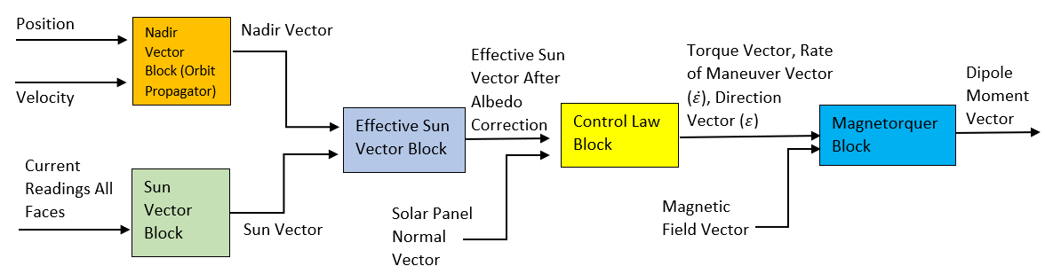

1. Determine sun vector using current production from solar panels on perpendicular faces of satellite. Additional sunlight gets reflected back due to Earth’s albedo, must correct this to accurately estimate sun vector. Equations for sun vector (before albedo correction) [1]:

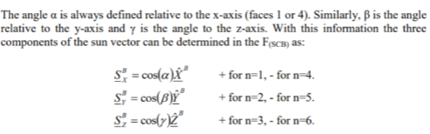

* 1. Albedo correction computation requires nadir vector. Nadir vector can be obtained from orbit simulations using existing Simulink *Orbit Propagator* block. Equations for nadir frame attitude quaternion:



* 1. Albedo correction is dependent on angle between sun and nadir vectors. Nadir vector represents direction of Earth’s albedo. Effective sun vector computed by adding variable nadir vector to sun vector. At maximum, Earth’s albedo accounts for 35% of incoming light. Thus the nadir vector gets scaled from 0 – 35% depending on the satellite’s position according to following table. Matlab file to compute effective sun vector attached in appendix [2].

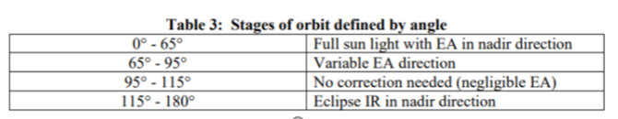

* 1. According to Matlab simulations, the variance in angle gets reduced from 20-degrees to 10-degrees after adding in albedo correction. Typical sun sensors achieve an accuracy of 0.0005 to 4 degrees [3], according to methods shown variance can range from 5 to 20 degrees (in worst-case without any correction algorithm). Comparatively this is a good start to begin experiments from.

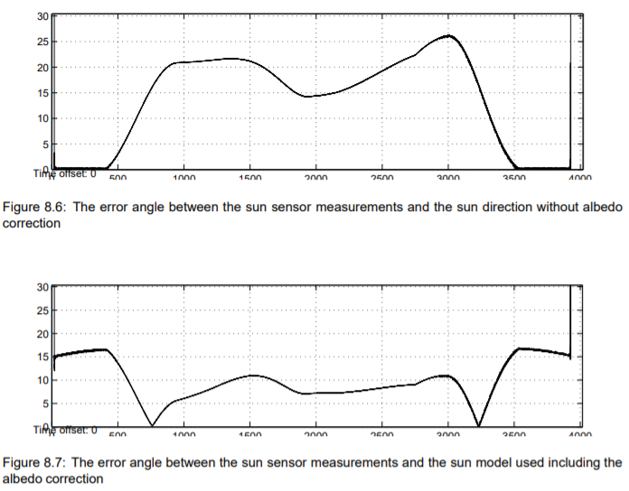

1. Effective sun vector combined with solar panel normal vector used to determine multiple parameters: torque, rate of maneuver, and direction of maneuver. All required to formulate control system that drives magnetorquers towards Sun.

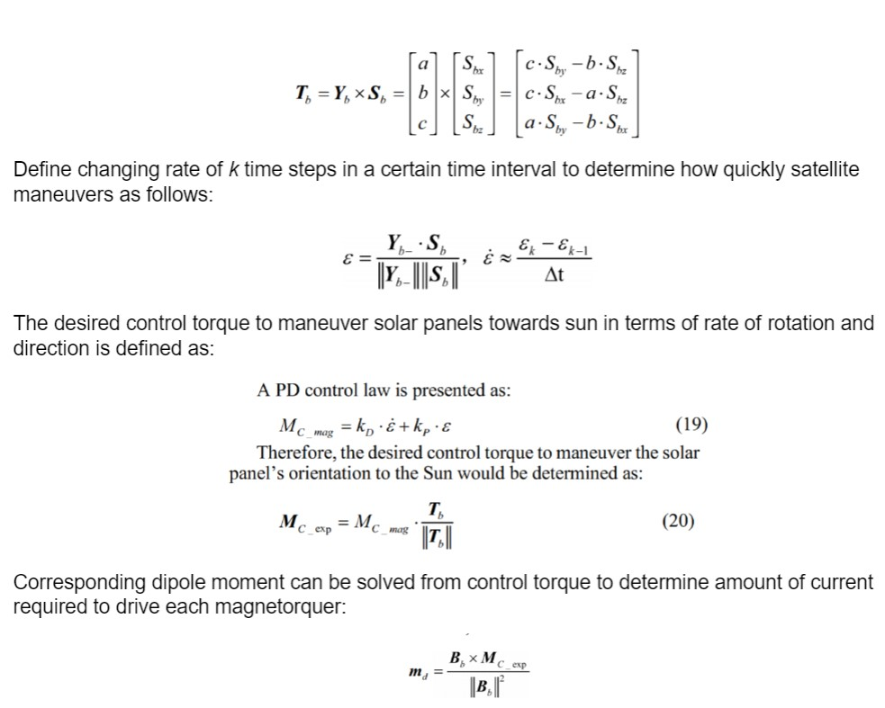

1. Magnetic dipole moment computed to drive magnetorquers using parameters from control law.



**Sources**

1. Gaebler J. Coarse Sun Sensing for Attitude Determination of CubeSat. Spring 2007. <https://ufdc.ufl.edu/AA00062245/00001>.
2. Krogh, K., Schreder E. Attitude Determination for AAU CubeSat. June 6, 2002. <http://www.amsat.org.ar/cubesat/aauACSD.pdf>.

**Appendix**

Compute Effective Sun Vector (EffectiveSunVec.m)

A = 29/100^2 %solar panel area (m^2)

eff = 0.24 %solar panel efficiency

K = 1380 %solar irradiance (W/m^2)

I0 = 4 * A * K * cosd(0) * eff %assuming 4 cells per panel -> 3.84W max

nadir = [5 4 3] %estimate for nadir vector for Albedo correction

correction = 0

%Coordinate vector defn

Xb = [1 0 0];

Yb = [0 1 0];

Zb = [0 0 1];

%Input current per each panel (assuming upto 6)

I = input('Input as [I1, I2, I3, I4, I5, I6]: ');

%Calculate alpha, beta, delta angles relative to each axis

%If solar panel in neg direction detects light, take angle relative to

%opposite side

%Else solar panel in pos direction detects light, take angle normally

if I(1)==0

alpha = 180 - acosd(I(4)/I0);

else

alpha = acosd(I(1)/I0);

end

if I(2)==0

beta = 180 - acosd(I(5)/I0);

else

beta = acosd(I(2)/I0);

end

if I(3)==0

gamma = 180 - acosd(I(6)/I0);

else

gamma = acosd(I(3)/I0);

end

Sb = [cosd(alpha) cosd(beta) cosd(gamma)];

disp(Sb)

%Check if albedo correction required by computing angle between sun sensor

%and nadir vector

%Accounts for field-of-view of albedo effect

%Fixed 100% of albedo accounted for

if atan2d(norm(cross(Sb, nadir)), dot(Sb, nadir)) < 65

%albedo correction requires nadir-vec to be 30% of sun-vec magnitude

nadir_mag = norm(Sb) * 0.35;

%scale nadir vec by required magnitude

nadir_unit = nadir / norm(nadir);

nadir_correction = nadir_unit * nadir_mag;

%corrected sun-vector

Sb = Sb + nadir_correction;

%Variable albedo accounted for

elseif atan2d(norm(cross(Sb, nadir)), dot(Sb, nadir)) > 65 && atan2d(norm(cross(Sb, nadir)), dot(Sb, nadir)) < 95

%scale factor from 0 - 1.0

correction = atan2d(norm(cross(Sb, nadir)), dot(Sb, nadir)) - 65 / 30;

nadir_mag = norm(Sb) * correction;

nadir_unit = nadir / norm(nadir);

nadir_correction = nadir_unit * nadir_mag;

Sb = Sb + nadir_correction;

end